**CONFIGURE AN HTTP LOAD BALANCER WITH AUTOSCALING**

**Presentation**

GCP HTTP (S) load balancing is implemented at the edge of the Google Network in Google Points of Presence (POP) around the world. User traffic directed to an HTTP (S) load balancer enters the POP closest to the user. Then, load balancing on Google's global network allows traffic to be routed to the nearest backend with sufficient capacity.

In this lab, you will configure an HTTP load balancer, as shown in the diagram below. You will then perform a stress test on the load balancer to verify the operation of global load balancing and autoscaling.

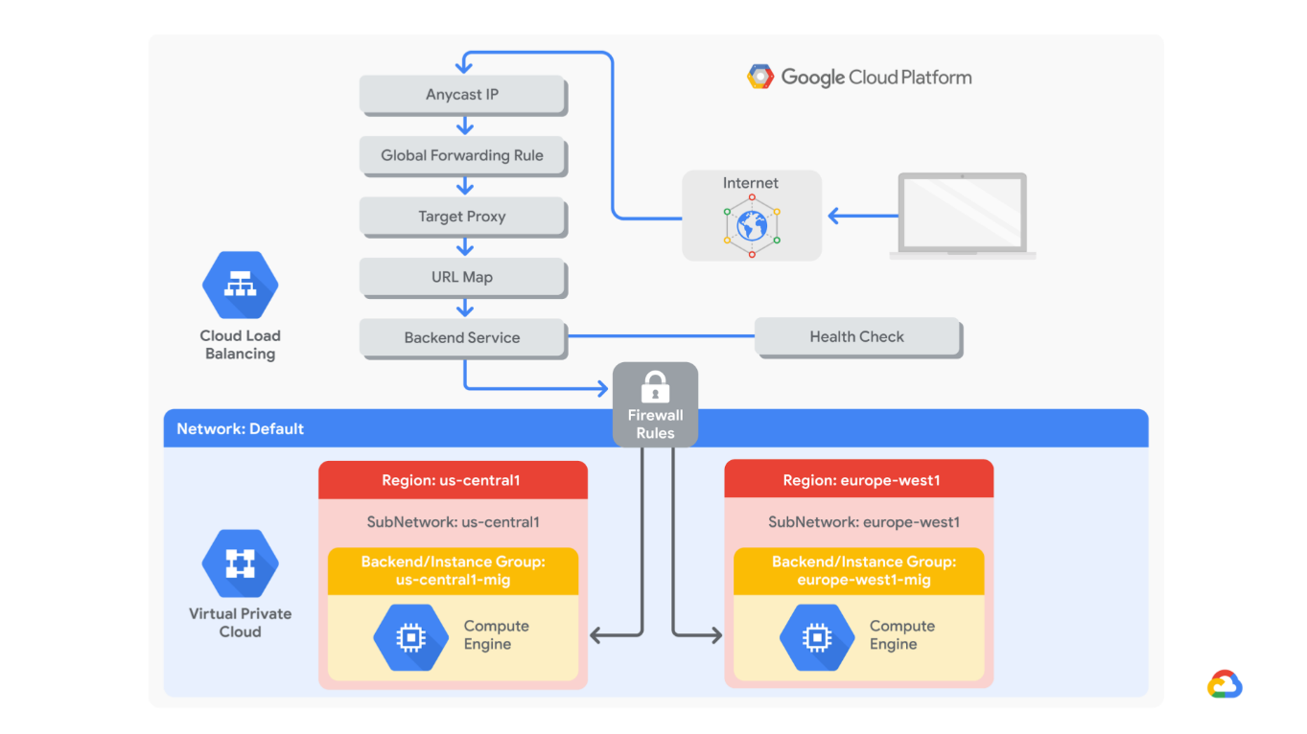

Goals

This workshop will teach you how to perform the following tasks:

* Create an HTTP firewall and health check rule
* Create a custom image for a web server
* Create an instance template based on the custom image
* Create two groups of managed instances
* Configure an HTTP Load Balancer with IPv4 and IPv6
* Stress Test on an HTTP Load Balancer

**Task 1: Configure an HTTP Firewall and Health Check Rule**

1. **Create the HTTP firewall rule**

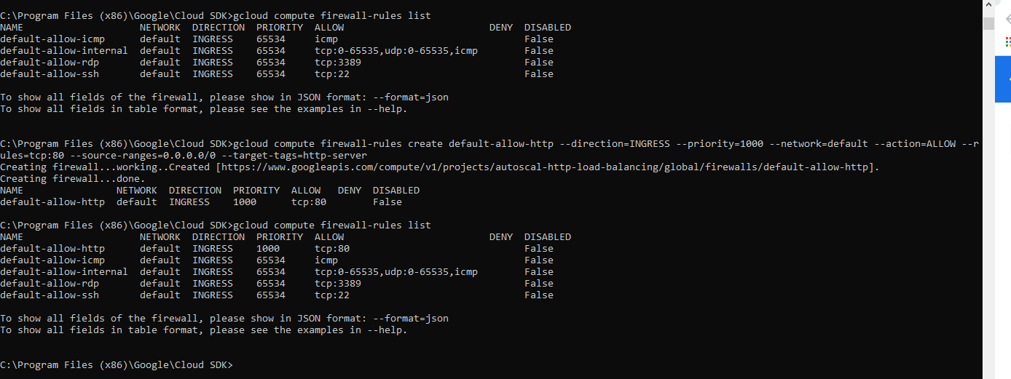

1. **Create the health check firewall rule**

Health checks determine which instances of a load balancer can receive new connections. For HTTP load balancing, health checks for your load balanced instances come from addresses in the ranges **130.211.0.0/22** and **35.191.0.0/16**. Your firewall rules should allow these connections.

Your **default-allow-http** firewall rule already allows connections from **0.0.0.0/0** for **tcp: 80**. Therefore, you will not need to create another health check firewall rule during this lab.

**Task 2: Create a Custom Image for a Web Server**

* 1. Create a VM

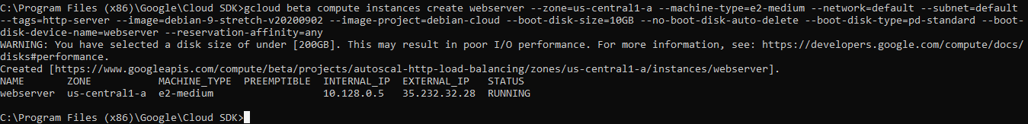

* 1. Customize the VM
* Connection with ssh to webserver

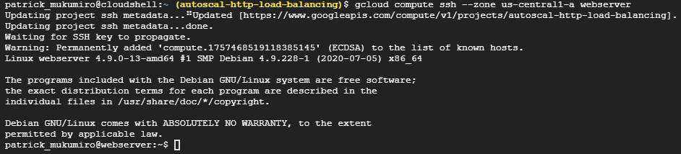

* To install Apache2, start Apache2 and Enable the start of the Apache service when the VM is launched

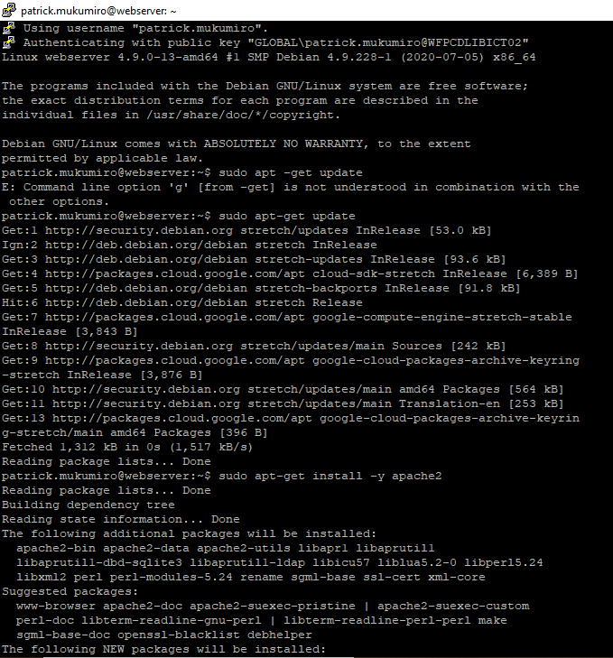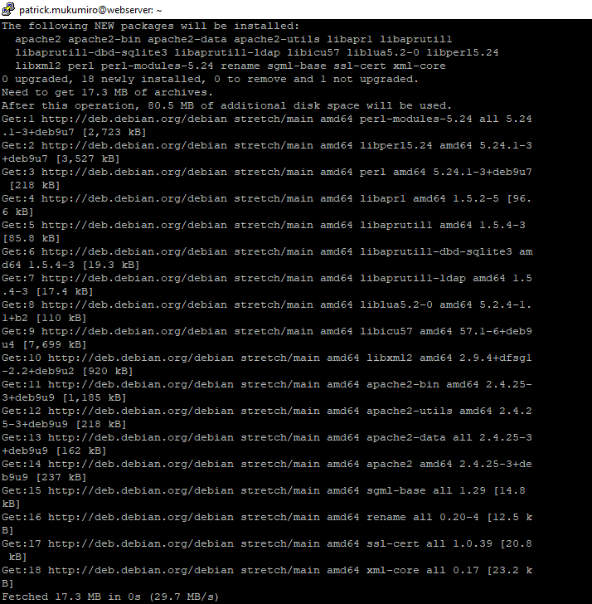

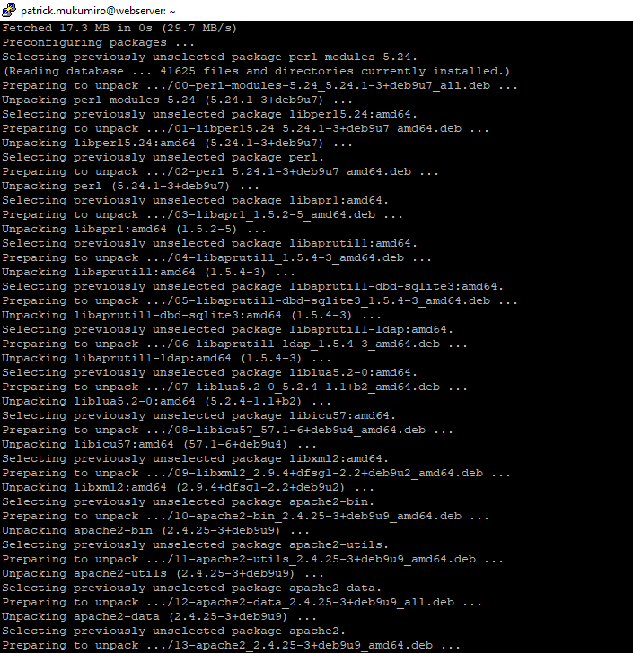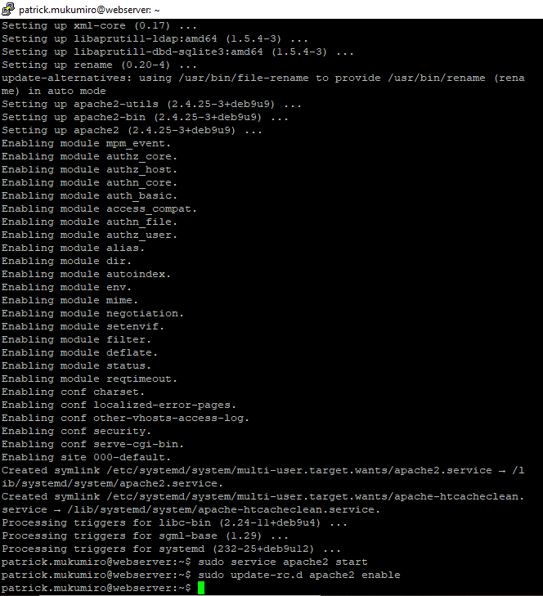

* 1. **Prepare the disc to create a custom image**
* Be sure to keep the startup disk when removing the instance.

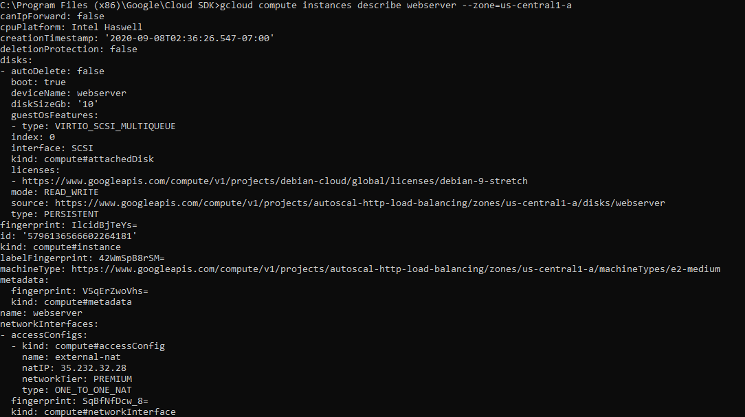



* Delete VM webserver

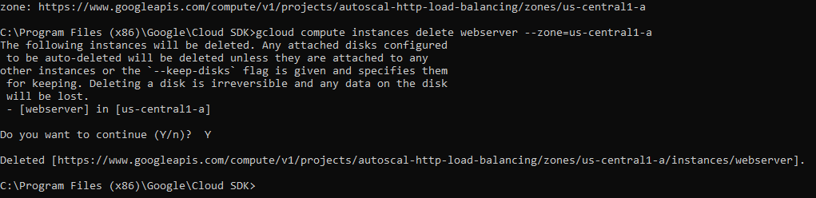

* check that the webserver disk and webserver instance exist

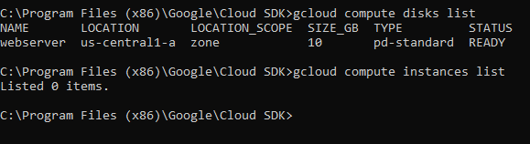

* 1. **Create custom image**

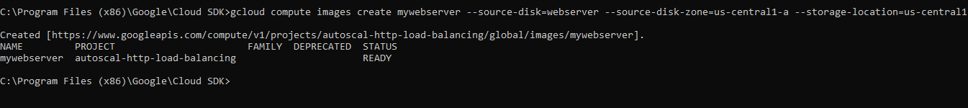

**Task 3: Configure an Instance Template and Create Instance Groups**

1. **Configure the instance template**

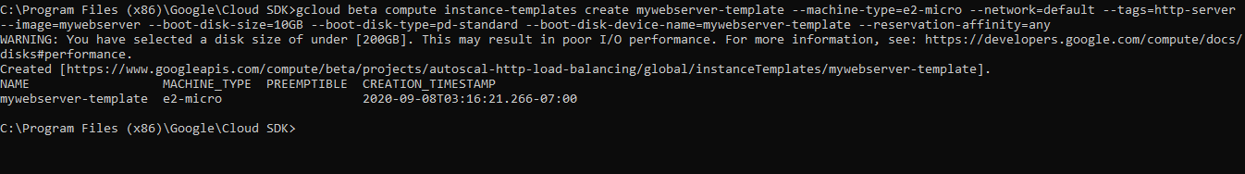

1. **Create the managed instance groups**

* Create a health check

* Create Instance group **us-central1-mig**

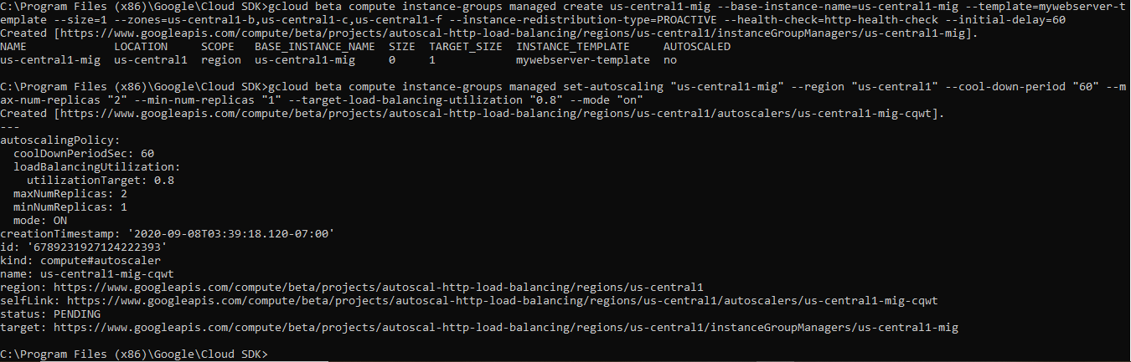

* Create Instance group **europe-west1-mig**

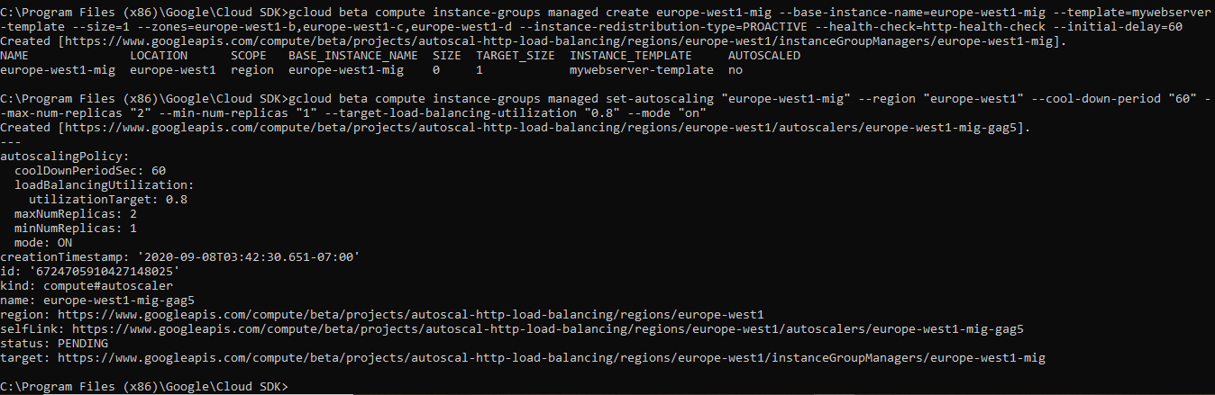

1. **Check backends**



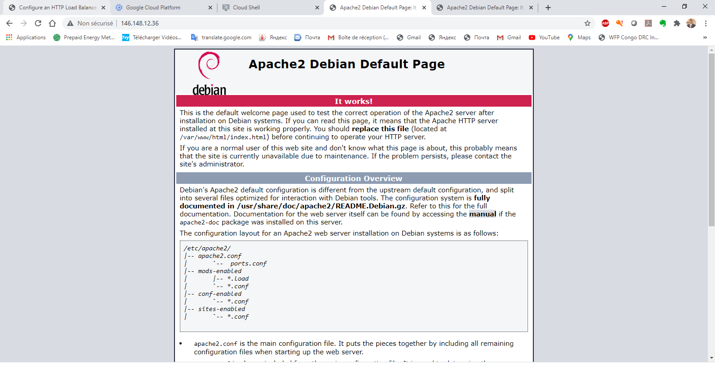

**Task 4: Configure the http load balancer**

1. **Configure the http load balancer**

* Create a backend service

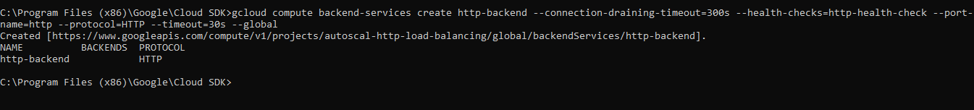

* Add your instances groups (us-central1-mig, us-europe-west1-mig) as a backend to the backend service

* Create a URL mapping



* Create a target HTTP proxy

* Create IPV4 and IPV6 global forwarding rules



**Task 5: Perform Stress Test on the HTTP Load Balancer**

1. **Access the HTTP load balancer**

* Show interfaces

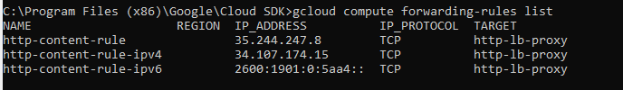

1. **Perform a stress test on the HTTP load balancer**

* Create a VM to simulate a load on the HTTP load balancer.



* Connection with ssh to the stress-test VM

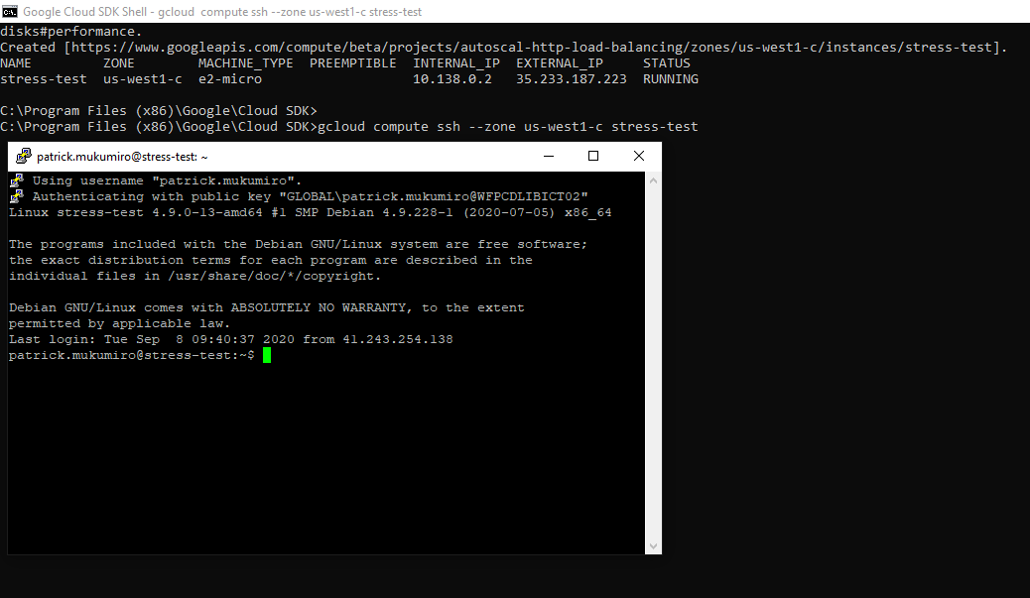

* create an environment variable for the IP address of the load balancer



* Place a load on the load balancer

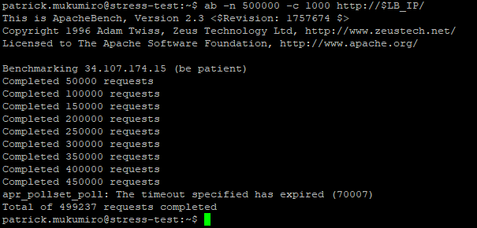

* Backend service details

